# JavaScript for Front-End – DOM Manipulations

Your task is to write the Front-End part of an application which renders information into HTML.

There are a few simple tasks. Those little tasks will ultimately combine into the functionality you need for the application itself.

## Rendering Data in HTML – 80 pts

In order for the HTML to look tidy and well formed, CSS needs to be applied, which suggests some specific element hierarchy and classes. Check the template and make sure your function renders the object correctly. You can see input and output below.

Create your functions for this task inside the jquery-data.js file, and implement them so that they render the data inside the jquery-data.html file.

### Render Form in HTML – 70 pts

#### Input

|  |
| --- |
| jquery-data.html |
| <**head**>  <**meta charset="utf-8"**>  <**link rel="stylesheet" type="text/css" href="service-estimate.css"**>  <**title**>Service Estimate</**title**> </**head**> <**body**> <**main**>  <**div id="header-ctr"**>   </**div**>  <**form**>   </**form**>  <**section class="after-success hidden"**>   </**section**> </**main**> </**body**> </**html**> |
|  |

#### Output

|  |
| --- |
| jquery-data.html |
| <!DOCTYPE **html**> <**html**> <**head**>  <**meta charset="utf-8"**>  <**link rel="stylesheet" type="text/css" href="service-estimate.css"**>  <**title**>Service Estimate</**title**> </**head**> <**body**> <**main**>  <**div id="header-ctr"**>  <**h1**>Basic calculated fields sample.</**h1**>  <**hr**/>  </**div**>  <**form**>  <**label class="one"**>  <**span**>Distance (mi) *</**span**>  <**input type="text" placeholder="Enter Distance" required**/>  </**label**>  <**label class="two"**>  <**span**>Weight (lb)</**span**>  <**input type="text" placeholder="Enter Weight" required**/>  <**span class="fragile"**>Fragile</**span**>  <**select name="fragile-menu"**>  <**option value="Value 0" disabled selected**>Select Something</**option**>  <**option value="Value 1"**>No</**option**>  <**option value="Value 2"**>Yes</**option**>  </**select**>  </**label**>  <**label class="three"**>  <**span**>Length (in)</**span**>  <**span class="height"**>height (in)</**span**>  <**span class="width"**>width (in)</**span**>  <**input type="number" placeholder="Length"**/>  <**input type="number" placeholder="Height"**/>  <**input type="number" placeholder="10" min="1" max="1000"**/>  </**label**>  <**label class="four"**>  <**h3**>Extra services:</**h3**>  <**p**><**input type="checkbox"**>Insurance</**p**>  <**p**><**input type="checkbox"**>Express Delivery</**p**>  </**label**>  <**label class="price"**>  <**span**>total:</**span**>  <**p class="total-price"**>$ 00.00</**p**>  </**label**> <**p class="submit"**>  Im Ready </**p**>  </**form**>  <**section class="after-success hidden"**>  </**section**></**main**></**body**></**html**> |

If you do everything correctly, you should see this:

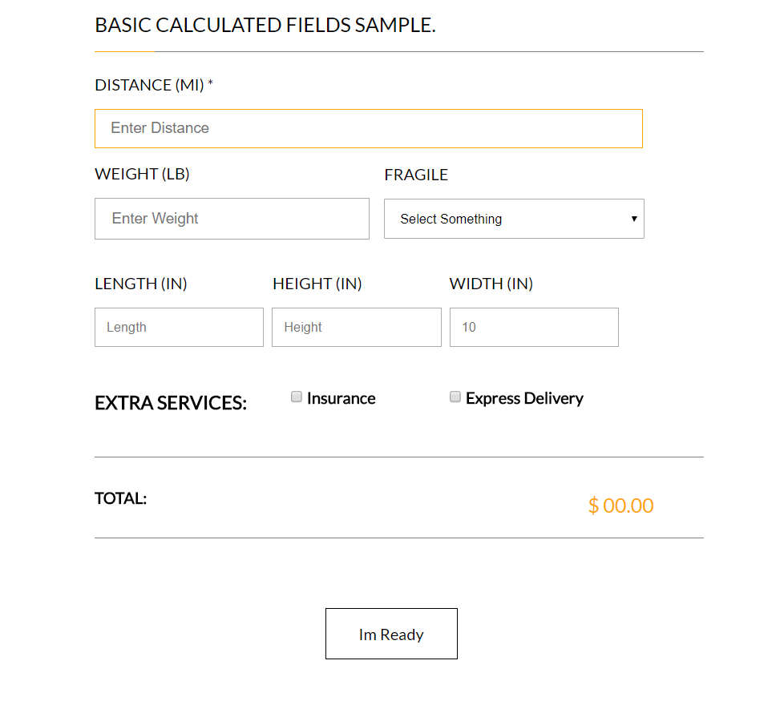

### Render Success Message In HTML – 10 pts

Render the date of single element like following:

#### Input

|  |
| --- |
| jquery-data.html |
| <!DOCTYPE **html**> <**html**> <**head**>  <**meta charset="utf-8"**>  <**link rel="stylesheet" type="text/css" href="service-estimate.css"**>  <**title**>Service Estimate</**title**> </**head**> <**body**> <**main**>  <**div id="header-ctr"**>  <**h1**>Basic calculated fields sample.</**h1**>  <**hr**/>  </**div**>  <**form**>  <**label class="one"**>  <**span**>Distance (mi) *</**span**>  <**input type="text" placeholder="Enter Distance" required**/>  </**label**>  <**label class="two"**>  <**span**>Weight (lb)</**span**>  <**input type="text" placeholder="Enter Weight" required**/>  <**span class="fragile"**>Fragile</**span**>  <**select name="fragile-menu"**>  <**option value="Value 0" disabled selected**>Select Something</**option**>  <**option value="Value 1"**>No</**option**>  <**option value="Value 2"**>Yes</**option**>  </**select**>  </**label**>  <**label class="three"**>  <**span**>Length (in)</**span**>  <**span class="height"**>height (in)</**span**>  <**span class="width"**>width (in)</**span**>  <**input type="number" placeholder="Length"**/>  <**input type="number" placeholder="Height"**/>  <**input type="number" placeholder="10" min="1" max="1000"**/>  </**label**>  <**label class="four"**>  <**h3**>Extra services:</**h3**>  <**p**><**input type="checkbox"**>Insurance</**p**>  <**p**><**input type="checkbox"**>Express Delivery</**p**>  </**label**>  <**label class="price"**>  <**span**>total:</**span**>  <**p class="total-price"**>$ 00.00</**p**>  </**label**> <**p class="submit"**>  Im Ready </**p**>  </**form**>  <**section class="after-success hidden"**>  </**section**></**main**></**body**></**html**> |

#### Output

|  |
| --- |
| jquery-data.html |
| <!DOCTYPE **html**> <**html**> <**head**>  <**meta charset="utf-8"**>  <**link rel="stylesheet" type="text/css" href="service-estimate.css"**>  <**title**>Service Estimate</**title**> </**head**> <**body**> <**main**>  <**div id="header-ctr"**>  <**h1**>Basic calculated fields sample.</**h1**>  <**hr**/>  </**div**>  <**form**>  <**label class="one"**>  <**span**>Distance (mi) *</**span**>  <**input type="text" placeholder="Enter Distance" required**/>  </**label**>  <**label class="two"**>  <**span**>Weight (lb)</**span**>  <**input type="text" placeholder="Enter Weight" required**/>  <**span class="fragile"**>Fragile</**span**>  <**select name="fragile-menu"**>  <**option value="Value 0" disabled selected**>Select Something</**option**>  <**option value="Value 1"**>No</**option**>  <**option value="Value 2"**>Yes</**option**>  </**select**>  </**label**>  <**label class="three"**>  <**span**>Length (in)</**span**>  <**span class="height"**>height (in)</**span**>  <**span class="width"**>width (in)</**span**>  <**input type="number" placeholder="Length"**/>  <**input type="number" placeholder="Height"**/>  <**input type="number" placeholder="10" min="1" max="1000"**/>  </**label**>  <**label class="four"**>  <**h3**>Extra services:</**h3**>  <**p**><**input type="checkbox"**>Insurance</**p**>  <**p**><**input type="checkbox"**>Express Delivery</**p**>  </**label**>  <**label class="price"**>  <**span**>total:</**span**>  <**p class="total-price"**>$ 00.00</**p**>  </**label**> <**p class="submit"**>Im Ready</**p**>  </**form**>  <**section class="after-success hidden"**>  <**h1**>Good Job!</**h1**>  <**img src="register_success.png" alt="success"**></**section**> </**main**></**body**></**html**> |
|  |

If you do everything correctly, you should see this:



**JQuery** may be used in this problem. It is **ADVISED** that you use **JQuery**, but **native DOM manipulation** is also allowed.

## Capture Click Event – 20 pts

Now let’s complete some tasks of handling click events. Write your code in events.js.

### Element Click Event – 20 pts

Your task is to **attach** a click event to **.submit**, which hides all of the content displayed **in Render Form in HTML**  and show all of the content created by **Render Success Message In HTML** .